Background to AutoMetricks.
Previously, generating Metricks for different regions of interest (ROIs) within the same montage had to be performed sequentially, which was time‑consuming. AutoMetricks was developed to address this limitation by enabling the simultaneous generation of Metricks for all ROIs extracted from a single montage.
In the Porter Lab, each generated ROI is expected to contain approximately 100 bcones. Accordingly, the program verifies the cone count for each ROI. Any ROIs that do not meet this criterion are flagged, and their names are automatically saved to an Excel file for further review.

Read Me for AutoMetricks
- Run autoROIMetricks matlab code

- Select Folder containing ROIs.
  - For correct naming, the program excepts the ROIs to be named with the “Location “space” Distance from Fovea. For example, for an ROI of Inferior 50 microns, Folder name should be = “Inferior 50”
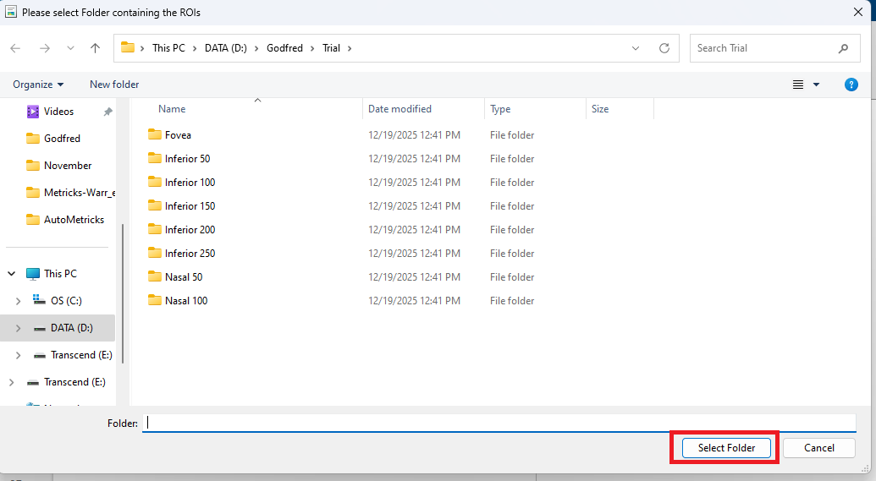
- Enter scaling in microns per pixels (Scaling parameters are applied to every ROI in the folder)
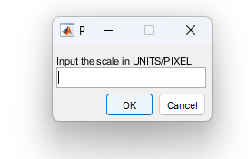
- Enter scaling in pixels per degree
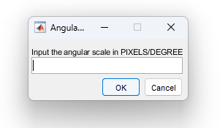
- Select the output units. Typically (microns (mm) density) is selected.
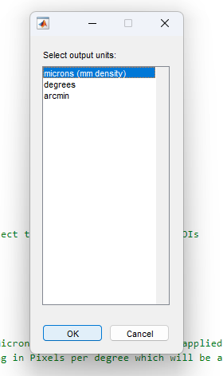
- Program runs

- If there are any ROIs which could not have the required number of Bound Cells, they are written in a CSV file.

  - For these ROIs, just get a larger ROIs size in Mosaics, and run the Program, “Coordinate_Mosaic_Metrics_non_Map_modified.m”

